Golay Nie 1001678015

CSE 5321 Homework 5

Spring 2019

1)

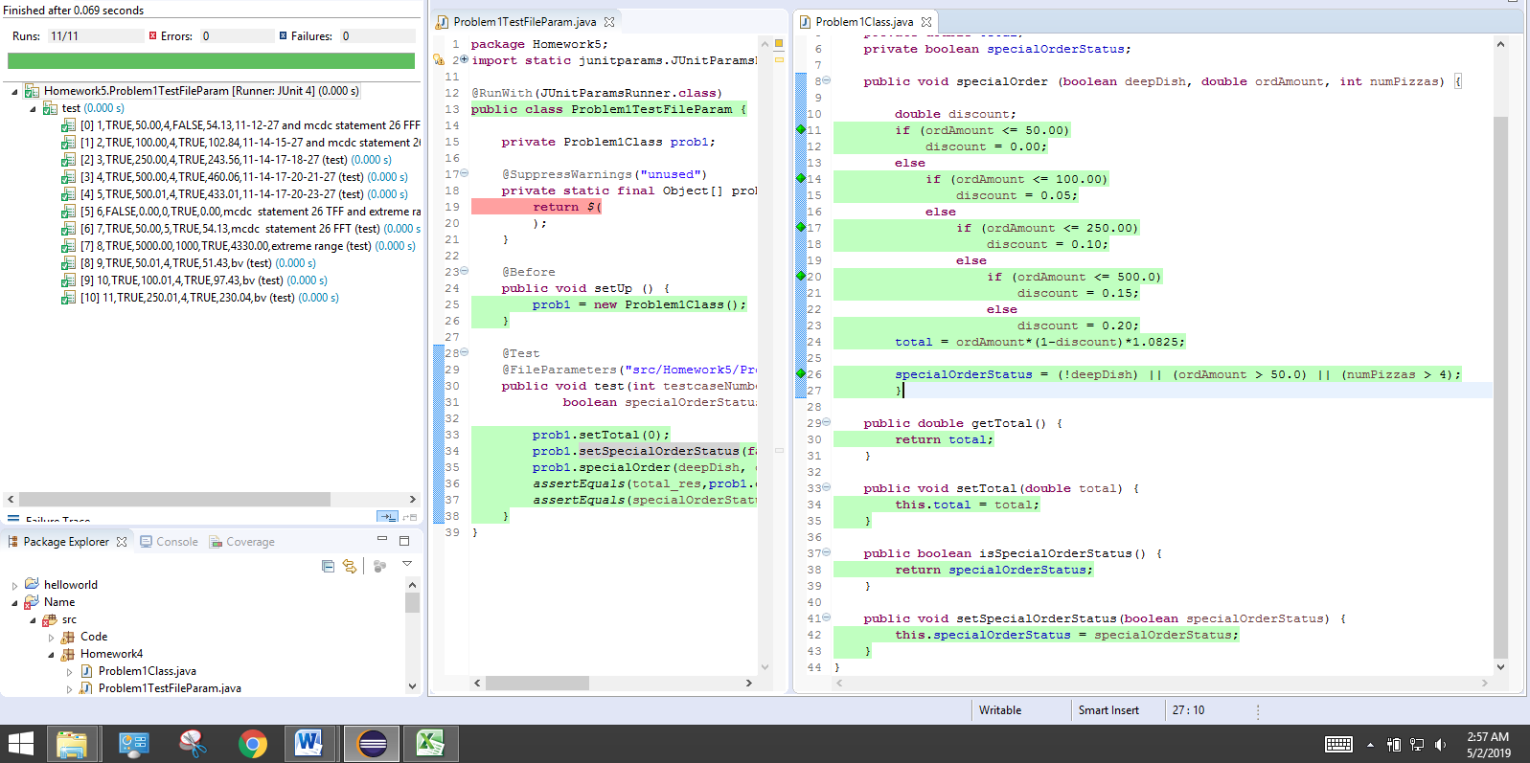

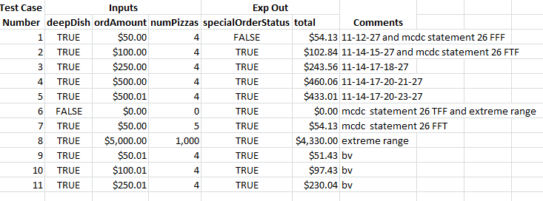

**2) provided test cases (JaCoCo is all green because it covers decision and conditional coverage, but PIT won’t be all green unless it gets in addition boundary value (BV) coverage:**

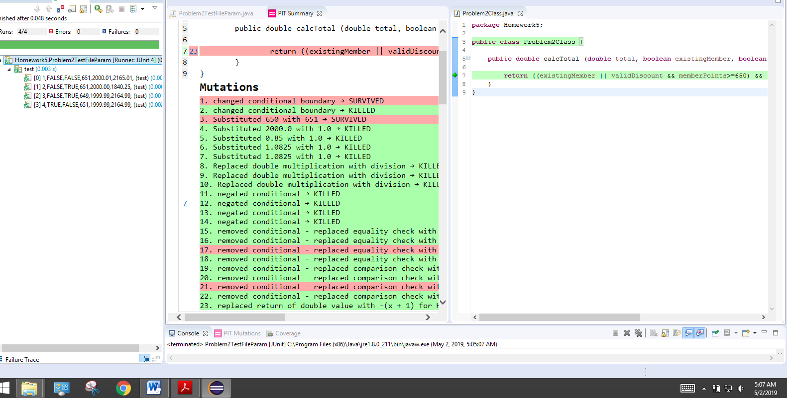

**2) My test cases:**

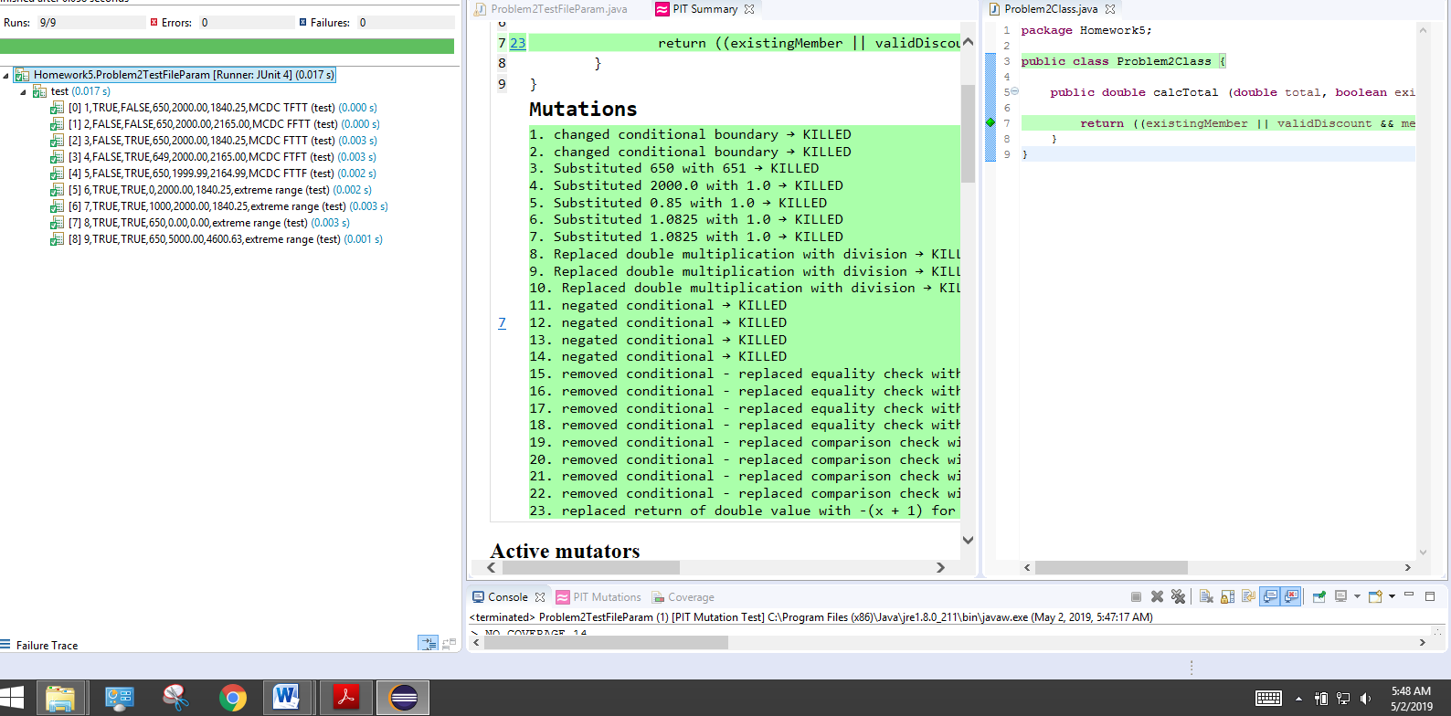

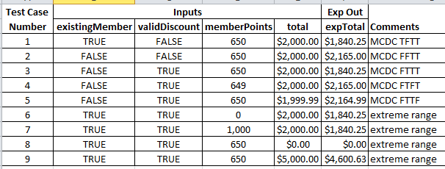

3)

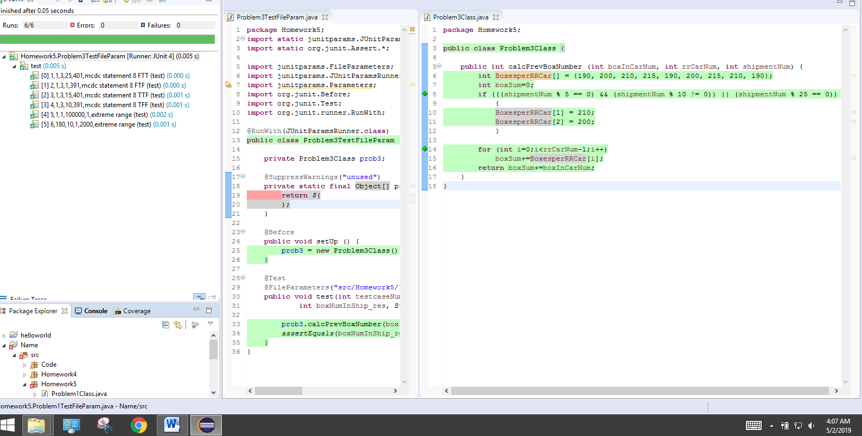

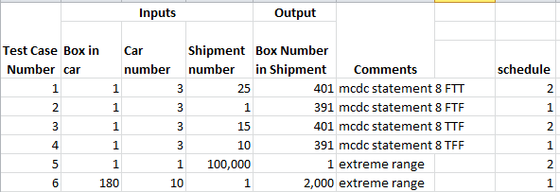

4) 3 of 9 tests failed. Same test table as #2.

